Nutrition for Fitness
Name
Institution
Date

Nutrition for Fitness
Introduction
Nutrition is food at work in the body.
According to Dalle Grave (2020), nutrition is how the organism ingests, digests, absorbs, transports, and uses the nutrients and egests the end product. 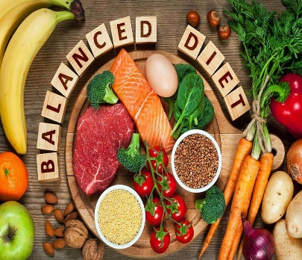
Every person needs nutrients for a healthy life.
Good nutrition helps a person to maintain healthy body weight and minimizes the risks of chronic illnesses.
Without proper nutrition, then average growth and development will not occur well.
Nutrition should be balanced with fitness for quality lives.
People have been diagnosed with chronic illnesses due to the lack of balance between eating habits and exercise rates.
In this brochure, the main focus is on nutrition and fitness.
Recommended Nutrition for General Fitness
A balance between the six essential nutrients is necessary for good healthy (Dalle Grave, 2020).
These nutrients include carbohydrates, proteins, fat, vitamin, minerals, and water.
The macro-nutrients, that is, carbohydrates, proteins, and fats, should make a more significant percentage of food.
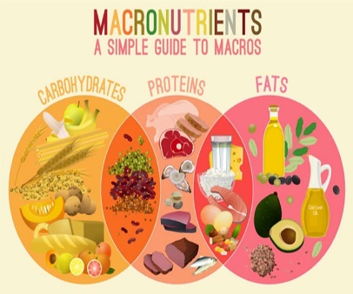
The vitamins and minerals are micronutrients that are needed in smaller amounts.
The Factors Determining the Number of Nutrients Needed in the Body
Age of the person.
Activity levels of an individual.
The amount of time one takes in training.
Nutritional health concerns.
Before exercise, one should take foods, including fatty fish, brown rice, sweet potatoes, water, and a banana.

At times one can take spinach, a piece of pineapple of papaya, a spoon of almond butter, a cup of chocolate milk, a part of the watermelon, and cheese.
During exercise, the recommendable foods include a banana for replenishing the nutrients supply and taking small amounts of water to stay hydrated (Bout-Tabaku, 2018).
After exercises, the oatmeal, an apple, berries, or bananas.
Diet Adjustments Due to Increased Physical Activity.
With increased physical activity, the body will need high energy diets.
Increasing the amount of eggs intake. For example, if one was taking eggs before exercise, they might decide to be taking two full eggs (Bout-Tabaku, 2018).
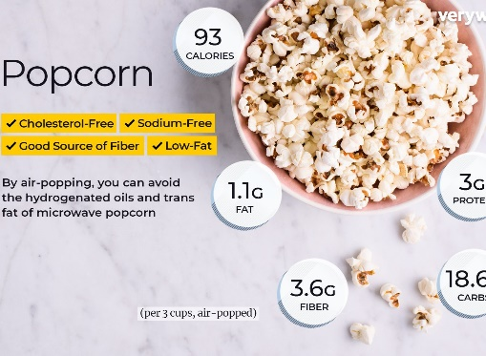
Taking popcorn can aid in increasing the carbohydrate levels for higher energy.
Greek yogurts add extra proteins and thus are worth eating.
Increase water intake to match the activity levels.
Nutrients Requirements in the Body.
Quality diets should contain 55% to 60% carbohydrates to give the body enough energy for normal functioning (Bout-Tabaku, 2018).
The recommendable amounts of fats should not exceed 15% of the total diet composition, which prevents the accumulation of excessive cholesterol in the body.
Lastly, 30% of a quality diet has proteins to build and repair the damaged tissues (Dalle Grave, 2020).
Most people need approximately 1,500 and 2,00 calories within a day.
A person involved in physical exercises needs to adjust the calories amount and take an extra 500 to 1,000 more calories within a day (Bout-Tabaku, 2018).
Recommended Fluid Intake in the Body
Men need to take at least 3.7 liters of water in a day.
For women, the recommendable amounts of water are 2.7 liters.
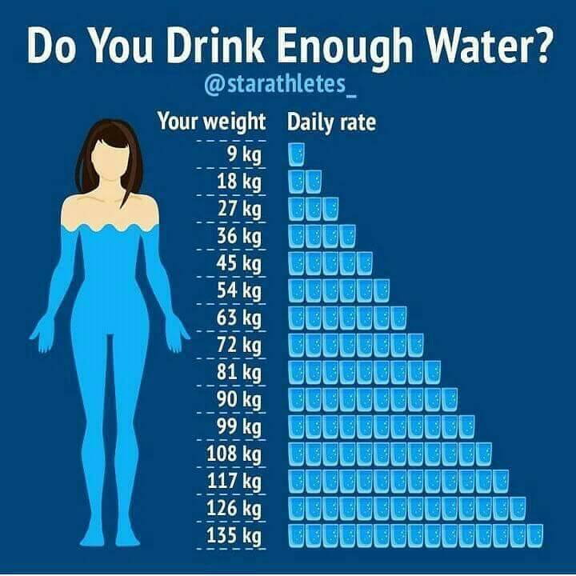
People who are involved in physical exercises should take at least 4 liters of water per day.
Essential Supplements
Food supplements are critical in providing vitamins, minerals, amino acids, and fatty acids in the body.

Supplements intake leads to a balance of nutrients in the body and avoids malnutrition (Dalle Grave, 2020).
Examples of food supplements needed for increasing energy in the body include; Cranberry, saw palmetto, garlic, and milk thistle.
NOTE: The FDA does not regulate dietary supplements, and thus people need to not their adverse effects before consumption.

References
Bout-Tabaku, S. (2018). General Nutrition and Fitness for the Child with Rheumatic Disease. Pediatric Clinics, 65(4), 855-866.
Dalle Grave, R. (2020). Nutrition and Fitness: Mental Health.

